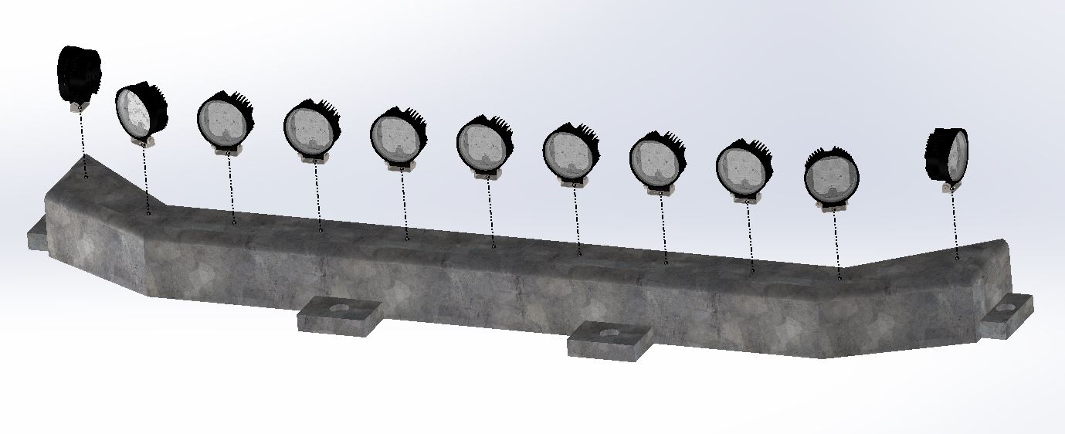

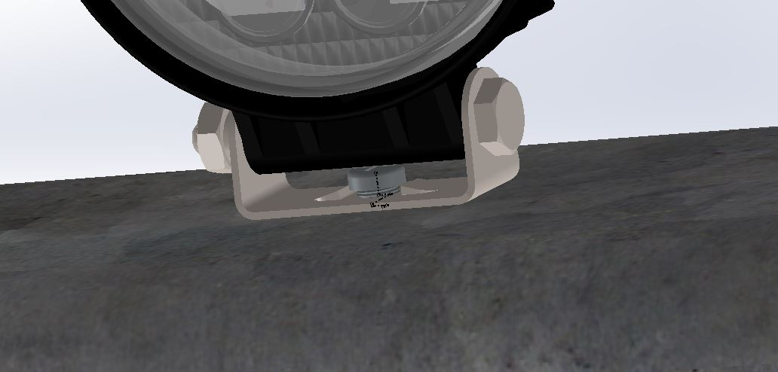Step 1: Place all 11 light subassemblies on top of the 11 pre manufactured holes in the light base.

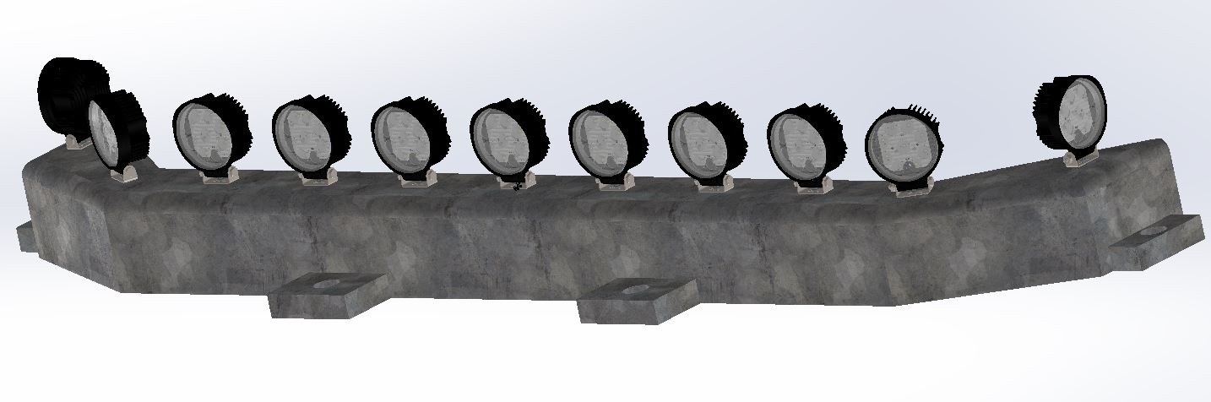Step 2: Screw each of the 11 light screws into each of the 11 holes in order to secure the lights into the light base.

Step 3: Complete the assembly by securely fastening each screw.